**4**

**Chocoholics Anonymous**



***Use Case Specification Document***

**03**

**Member Payment**

**Version No. 1.0**

**Project Document Revision History**

|  |  |  |  |
| --- | --- | --- | --- |
| **VersionNumber** | **Date** | **Revision Author** | **Description of Revision** |
| 1 | 06/09/2019 | Mohanapriya Kottan Rajaraman | Initial Version |
| 2 | 07/14/2019 | Zaid Alsafi | Revision of Initial Version |

|  |
| --- |
| **Table of Contents** |

Introduction 3

Use Case Information 4

Actors 4

Use Case Interaction 4

Trigger 4

Pre-condition(s) 4

Post-condition(s) 4

Use Case Swimlane (Activity) Diagram 5

Main/Basic Flow(s) of Events (Happy Path) 5

Alternate/Exception Flow of Events 6

Assumptions/Business Rules including Non-Functional Requirements 6

Use Case Specification Review and Signoff7

# Introduction

This Use Case highlights Chocoholic Anonymous members payment process. Members pay monthly fees to ChocAn for which they are entitled to unlimited treatments and consultations with health care professionals. Membership status is validated against the monthly payment when the member approaches providers to avail services. If the monthly payment is not made, membership status goes to suspended and he/she won’t be able to avail service until the payment is made and membership status activated again.

# **Use Case Information**

## Actors

|  |  |  |
| --- | --- | --- |
| **Actor Name** | **Role** | **Description** |
| Member | Main | Makes payment to ChocAn on a monthly basis. |
| AAS | Main | Manages the member fee and status. |
| Time | Main | Triggers the AAS every day at 9pm to start the validation. |
| System | Secondary | When member handles the card to provider to avail service, system dials the data center to validate the Card and membership status. |

## **Use Case Interaction**

**Predecessor** :

Manage Registration - (Use Case 01-)- A member must be registered with ChocAn Data Center system and get a member card to take the services provided by the Provider.

**Successor :**

Provide Track Service - (Use Case 05) - A member receives the services after making the payment so they can track services.

# Trigger

Time triggers AAS to check for the payment received and updates the membership status.

# **Pre-condition(s)**

Below are the preconditions required for providers payment process :

* 1. A member must be registered with ChocAn Data Center.

# **Post-condition(s)**

Possible outputs on completion are listed below :

* 1. ~~Providers provide Services to the Member.~~
  2. Update Membership
     + 1. Membership is Active
       2. Membership is Suspended

# **Use Case Swimlane (Activity) Diagram**

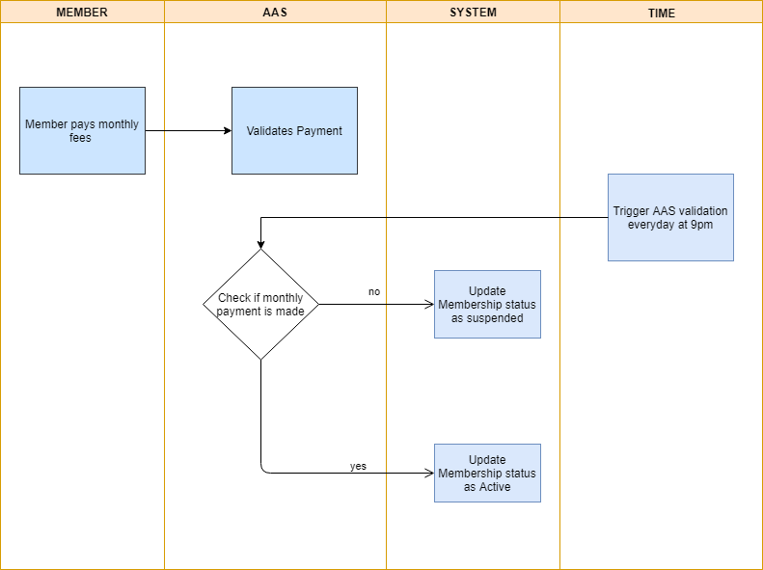

# **Main/Basic Flow(s) of Events (Happy Path)**

* 1. ~~ChocoAn DataCenter system registers the member. First month payment is made by the member and membership status is active.~~
  2. ~~In the coming months, if member doesn’t make payments, AAS puts the membership status to Suspended.c~~
  3. Member Status is updated to active or suspended.
  4. Member Pays monthly Fees

# Alternate/Exception Flow of Events

* 1. No Data Present on the ChocoAn DataCenter System.
  2. Error processing Member payment.
  3. Error processing Membership status.

# Assumptions/Business Rules including Non-Functional Requirements

None

# **Use Case Specification Review and Signoff**

|  |  |  |  |  |
| --- | --- | --- | --- | --- |
| **Review and Signoff of the Use Case Specification** | | | | |
| **Name** | **Project Team Role** | **Signature** | **Date** | |
| Tejaswi Dasyam | Team Member | tejaswi | 06/11/2019 | |
| Vaishali Jain | Team Member | vaishalijain | 06/11/2019 | |
| Khushmeet Kaur | Team Member | khushmeetkaur | 06/11/2019 | |
| Mohanapriya Kottan Rajaraman | Team Member | Mohanapriya | 06/11/2019 | |
| Kopal Shinde | Team Lead | kopal | 06/11/2019 | |